|  |  |  |  |
| --- | --- | --- | --- |
| \\lyng-dc1\StaffShared\Learning Bugs Animals ALL subjects\characters bugs animals\Cyril the Snail - History.jpeg**Lyng Primary School Knowledge Organiser** | | | |
| **History Topic:** | **Great and Ghastly Events**  **Titanic** | Year 1 | Spring 1 |

|  |  |
| --- | --- |
| **What Step On and Goldilocks words will I use?** | |
| **Spelling** | **Definition** |
| iceberg | A large floating mass of ice that has broken from a glacier. |
| glacier | A large mass of ice formed in cold regions from compacted snow and very slowly moving down a slope or across land. |
| survivor | A person who survives. |
| unsinkable | Unable to sink |
| lifebelt | A life saver that fastens around a person's waist like a belt. |
| lifeboat | a boat made for quick rescue of people. It can be carried on a larger boat, or it can be used from shore. |
| passengers | a person who is not driving, but travels in an automobile, bus, train, or other vehicle. |
| collision | an act or instance of coming together with force; crash. |
|  |  |
|  |  |
|  |  |
|  |  |

**Background information for parents and teachers**

RMS Titanic was a British passenger and mail carrying ocean liner, operated by the White Star Line. It sank in the North Atlantic Ocean on 15 April 1912 as a result of striking an iceberg. The journey was from Southampton, England, to New York City, United States.

Of the estimated 2,224 passengers and crew aboard, about 1,500 died, making it the deadliest sinking of a single ship up to that time. The disaster drew public attention, spurred major changes in maritime safety regulations, and inspired many artistic works.

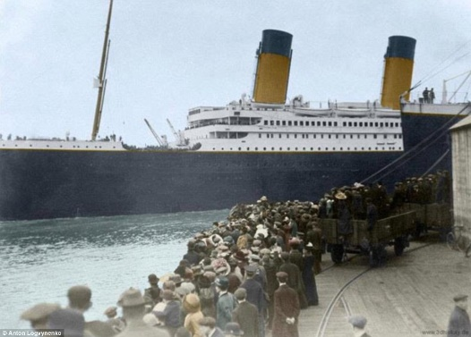

|  |
| --- |
| **When? (Timeline of key events)** |

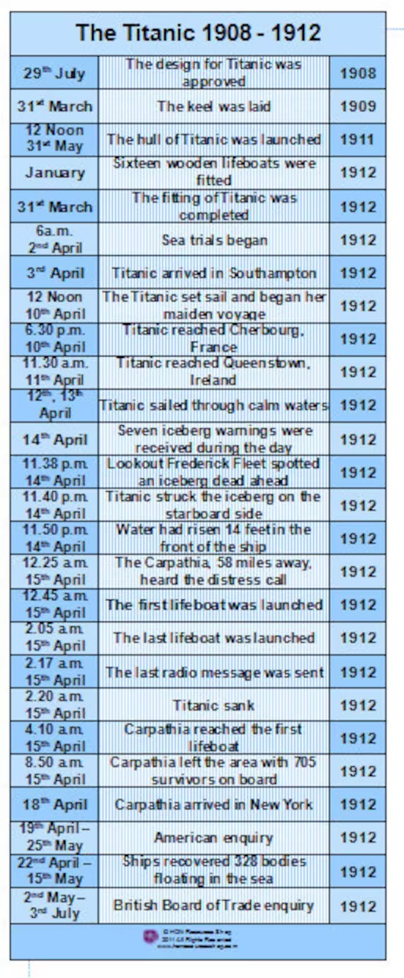

**Hook** 

Make a ship in the hall, design a ticket and go on-board the ship.

**Great Quotes**

**TRIP/VISITOR**

Immersive room

"There is no danger that Titanic will sink. The boat is unsinkable and nothing but inconvenience will be suffered by the passengers."

-Phillip Franklin, White Star Line Vice-President

**Our Storytelling Approach to enhance engagement**

|  |  |  |
| --- | --- | --- |
| **People:**  Eva Hart | **Place:**  Titanic ship | **Problem:**  It has sunk. Will Eva Hart survive? |

**Key People**

**Agreed Outcome**

Write a newspaper article.

**Eva Hart** - “I saw that ship sink … I saw it, I heard it, and nobody could possibly forget it.” She remembered the stars shining overhead and the terrible stillness of the scene broken up by the screams of survivors.

**John Jacob Astor IV** - Famous for marrying is his wife Madeleine on September 11th 1911, who at the time was only 18 years old. Also he was the richest man aboard the ship, when his body was recovered he had $2440 on him.

**Captain Edward John Smith** - Famous for being nicknamed the millionaires captain, it became a custom for the company to appoint him to the command of each of their finest ships as it came into operation.

**Thomas Andrews** - Famous for being the designer of Titanic and he was last seen by a steward looking at a painting of Plymouth.

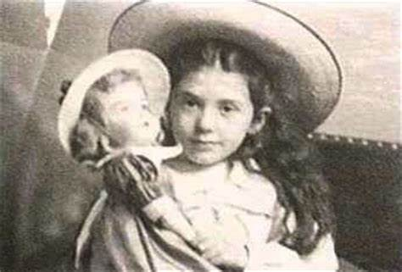

**Key skills – Taken from Milestone 1 – Sequence of Learning**

* Observe or handle evidence to ask questions and find answers to questions about the past.
* Ask questions such as: What was it like for people? What happened? How long ago?
* Use artefacts, pictures, stories, online sources and databases to find out about the past.
* Identify some of the different ways the past has been represented.
* Describe historical events.
* Describe significant people from the past.
* Recognise that there are reasons why people in the past acted as they did.
* Place events and artefacts in order on a time line.

|  |  |  |  |
| --- | --- | --- | --- |
| \\lyng-dc1\StaffShared\Learning Bugs Animals ALL subjects\characters bugs animals\Cyril the Snail - History.jpeg**Lyng Primary School Knowledge Quiz** | | | |
| **History Topic: Great and Ghastly Events** | **Titanic** | Year 1 | Spring 1 |

|  |  |  |
| --- | --- | --- |
| 5. Where was the Titanic going? | **S** | **E** |
| Southampton |  |  |
| North Pole |  |  |
| New York |  |  |

|  |  |  |
| --- | --- | --- |
| 1. Where did Titanic sink? | **S** | **E** |
| Indian ocean |  |  |
| Atlantic ocean |  |  |
| Pacific ocean |  |  |

**Our Titanic Quick Quiz**

|  |  |  |
| --- | --- | --- |
| 1. How many people died on the Titanic? | **S** | **E** |
| 5 |  |  |
| 1600 |  |  |
| 1500 |  |  |

|  |  |  |
| --- | --- | --- |
| 1. Did Eva Hart survive? | **S** | **E** |
| Yes |  |  |
| No |  |  |

|  |  |  |
| --- | --- | --- |
| 1. What did the Titanic hit into? | **S** | **E** |
| castle |  |  |
| iceberg |  |  |
| Another ship |  |  |